# Assignment-11

**Task 1:**

**Load t and y from ground_ motion.npz. Plot acceleration versus time. Comment on visible trends**

**or offsets. Hint: The signal should oscillate around zero for a stationary accelerogram.**

**Objective:**  
To preprocess and correct raw earthquake ground motion acceleration data by removing instrument-induced baseline drift, transient offsets, and extracting relevant frequency content

**1. Introduction**

Earthquake ground motion data often contains imperfections such as baseline drift, sudden offsets, and high-frequency noise due to instrument bias or setup artifacts. Uncorrected signals can lead to errors when integrated for velocity and displacement computations. This report describes a data processing pipeline focused on detrending, baseline correction, and spectral analysis of measured accelerogram data.​

**Conclusion:**  
The implemented processing steps successfully corrected baseline drift, removed sudden offsets, and clarified the true dynamic content of the measured ground motion. This ensures improved physical reliability for further engineering analysis, including velocity/displacement integration and structural response modeling.

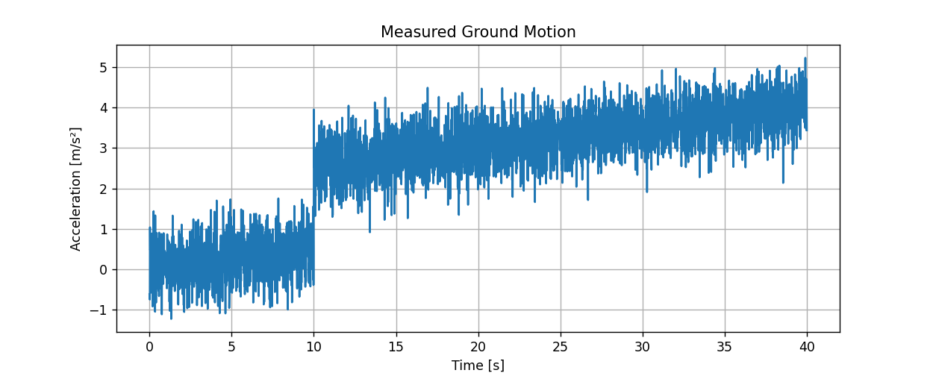

**Task 2: Construct matrix A with columns:**

* 1. Ones (intercept y0)
  2. Times t (rate r)
  3. Offset column as a step function u(t−offset_ time) (offset o)

**Purpose:**

the aim is to represent the measured signal as a combination of three fundamental components

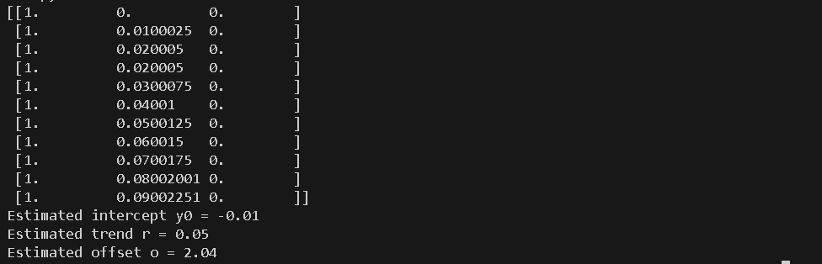

**Outcome:**  
By combining these columns, you get a design matrix A that accurately describes the physical and non-physical features in your data. This matrix is used for least-squares fitting in Task 3 to estimate the actual values of bias, linear trend, and offset, enabling precise correction of your measured signal.

**Task 3: Use scipy.linalg.lstsq to solve  *X^=(ATA)−1ATyX^=(ATA)−1ATy with X=[y0,r,o]TX=[y0,r,o]T.***

**Purpose:**  
Using the regression matrix A*A* constructed in Task 2 and the measured acceleration data (y), you want to solve for the best-fit parameters:

* y0: the constant bias or baseline drift
* r: the linear trend rate
* *o* : the step offset occurring at the chosen offset tim

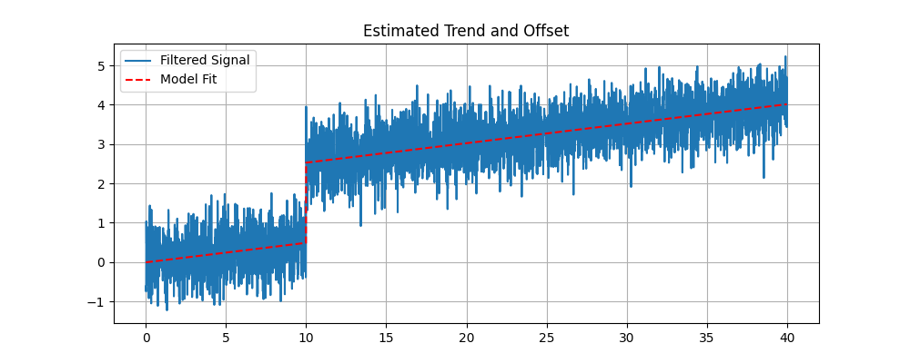

**Task 4: Compute the clean signal by subtracting the trend and offset**

$$yclean(t)=y(t)-(y^0+r^t+o^u(t-offset_time))$$

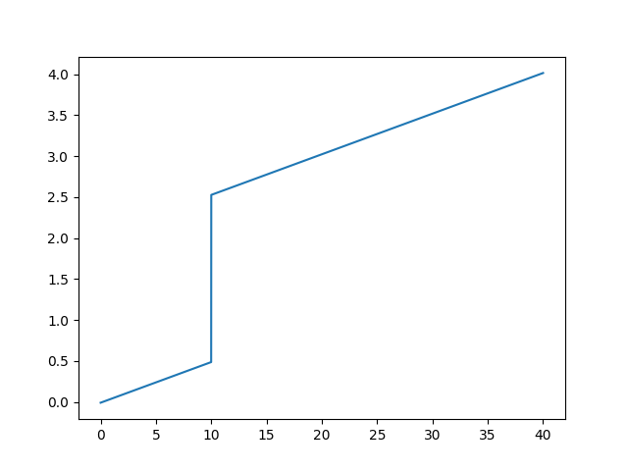

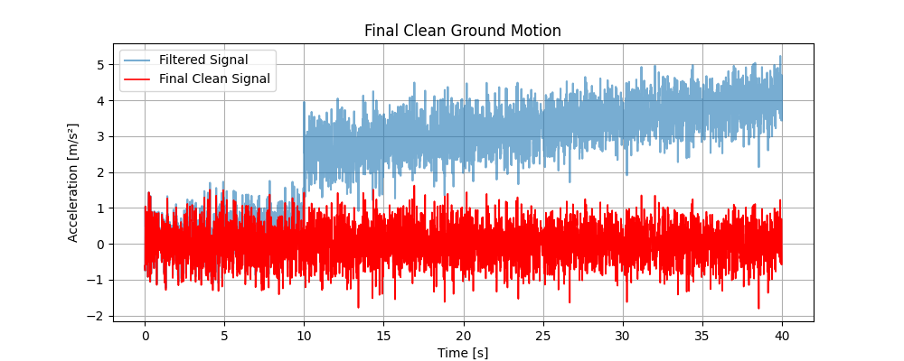

**Task 5: Compute and plot FFT amplitude vs frequency of cleaned signal.**

